Binned-Profile Model  
Color Correction for Optical See-Through Displays

1st Author

1st author's affiliation  
1st line of address  
2nd line of address  
Telephone number, incl. country code

1st author's E-mail address

2nd Author

2nd author's affiliation  
1st line of address  
2nd line of address  
Telephone number, incl. country code

2nd E-mail

3rd Author

3rd author's affiliation  
1st line of address  
2nd line of address  
Telephone number, incl. country code

3rd E-mail

**ABSTRACT**

Optical see-through displays allow users to view digital content and physical objects simultaneously. In such displays, light coming from background objects mixes with the light originating from the display, causing what is known as the color blending problem. Color blending negatively affects the usability of optical see-through displays as it impacts the legibility and color encodings of digital content, preventing wider adoption of such technologies. Color correction aims at reducing the impact of color blending by finding an alternative color which, once blended with the background, results in the original color.

In this paper we explore a color correction approach based on two display-induced distortions: (1) each display renders colors differently and (2) background colors are changed by the display medium before blending. We show how significant these two distortions are in see-through displays and propose the binned-profile (BP) model to address the first distortion. For a given display the BP model uses a colorimetric profile of how such display renders colors; with colors binned to a small set of “noticeably different” colors. We validate our model by measuring how accurately it predicts color blending as compared to other models. Then, we introduce a color correction algorithm and measure its correction capacity for different sets of background and foreground colors. We studied our model’s accuracy and our algorithm’s capacity of correction with an extensive set of colors on different displays devices. Results show the BP model can accurately predict color blending within 9 just noticeable differences in the worst case scenario. Results also show how light foreground colors can be better corrected in general, with neutral and cyan performing better for high intensity backgrounds. Finally, we elaborate on the applicability and design implications of our approach.

**General Terms** H.5 [Information Interfaces and Presentation]: H.5.1: Multimedia Information Systems — Artificial, Augmented, and Virtual Realities; H.5.2: User Interfaces — Ergonomics, Evaluation / Methodology, Screen Design, Style Guides

Permission to make digital or hard copies of all or part of this work for personal or classroom use is granted without fee provided that copies are not made or distributed for profit or commercial advantage and that copies bear this notice and the full citation on the first page. To copy otherwise, or republish, to post on servers or to redistribute to lists, requires prior specific permission and/or a fee.

*Conference’10*, Month 1–2, 2010, City, State, Country.

Copyright 2010 ACM 1-58113-000-0/00/0010 …$15.00.

**Keywords** Color Blending, Optical See-through Displays, Color Binning, Color Correction, Color Perception.

# INTRODUCTION

Optical see-through displays come in multiple form factors (e.g. head mounted displays, projection-based and transparent OLEDs) and are widely used in augmented reality (AR) applications including medical, maintenance, education and training (see 8[4][7] for a comprehensive list of applications). Although other technologies can also be used for AR (e.g. video see-through displays), optical see-through displays have the advantage of letting users see the real world with their own eyes at high fidelity while preserving properties like lighting, texture, color, age and wear. With a few consumer electronics starting to adopt them [12][9] and the continuous development of transparent LCD (Samsung NL22B [[link](http://www.samsung.com/us/business/commercial-display-solutions/LH22NLBVLVC/ZA)], Eyevis [[link](http://www.eyevis.de/index.php?article_id=163&clang=1)], RichTech [[link](http://www.richtechsystem.com/html/transparent-video-showcase.html)]) and OLED displays (Futaba Corporation [[link](http://www.oled-info.com/futabas-oled-road-map-amoleds-2014-transparent-and-flexible-oleds-cars-2015)], Fujitsu [[link](http://www.fujitsu.com/be/Images/Workplace_of_the_Future.pdf)], Winstar [[link](http://www.winstar.com.tw/newspaper_ov.php?lang=en&ID=153)]) we expect they will be widely available.

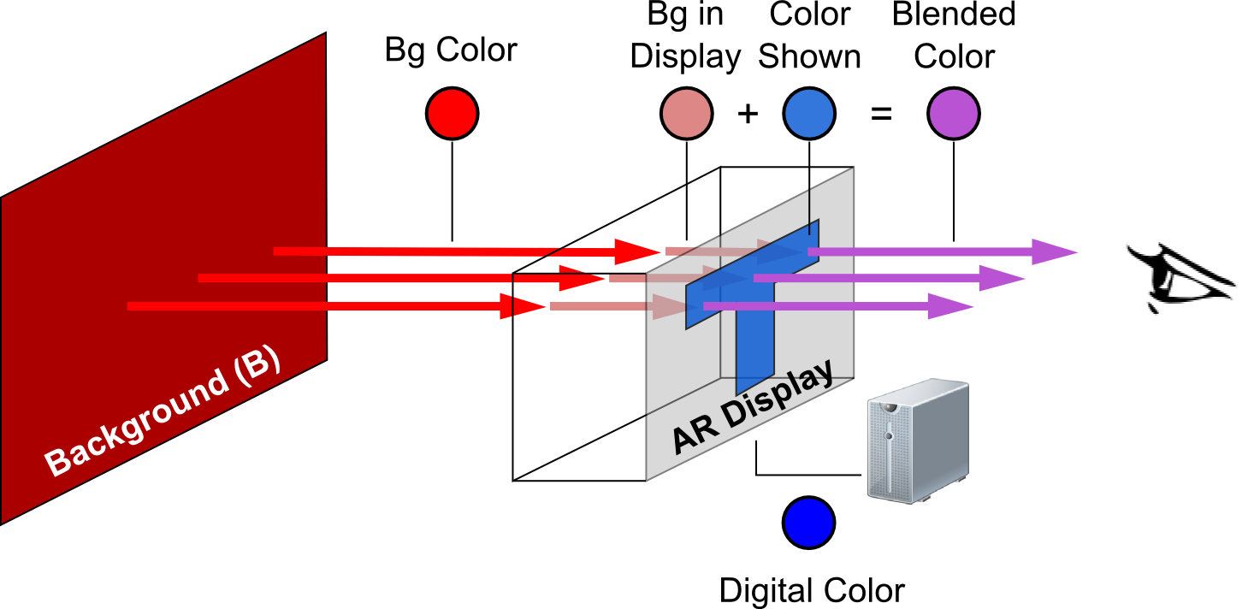

Figure 1. Color blending including the screen distortions for background and digital colors.

An important aspect of optical see-through displays is that light coming from real-world objects mixes with the light emitted by the display. This phenomenon is known as color blending [10]. Color blending is an important issue as it affects the legibility and color-encodings of digital information and compromises the general usability of such devices. Existing solution include using an spatial light modulator (SLM) to block background light, an approach requiring extra hardware on the display at the cost of non-transparency. Another solution is called color correction, and it requires the system to find an alternative digital color which, upon blending with the background comes closest to the desired digital color. Researchers have applied color-correction by subs-tracting “the background [color] from the virtual part pixel per pixel” [32], however no measure of its effectiveness was reported.

In this paper we argue that effective color-correction depends on an accurate color blending model, and that such model needs to take into account two distortions introduced by the display (see Figure 1) and ignored in previous work: (1) the way a particular display renders colors, and (2) the effect of the display medium on the background color. In this paper we focus on the first distortion and propose the binned-profile (BP) model: a model that divides the continuous universe of colors into discrete and finite bins and measures how a display actually renders each bin. We account for the second distortion through objective measures of how background colors are seem through the display.

We validate the BP model against other display models: the direct model (called the trivial correction in [32]), and the chromatic adaptation transformation (CAT) model. The direct model ignores the effect of the display on the digital colors, the CAT model uses known transformation matrices to determine the way a display shows particular colors. Our validation compares the capacity of each model to predict color blending. We used a colorimeter to measure the resulting blend of different background and foreground colors on three optical see-through displays. Based on this measurement we computed the accuracy of the different prediction models. Results showed that prediction with the BP model outperforms other for all three displays.

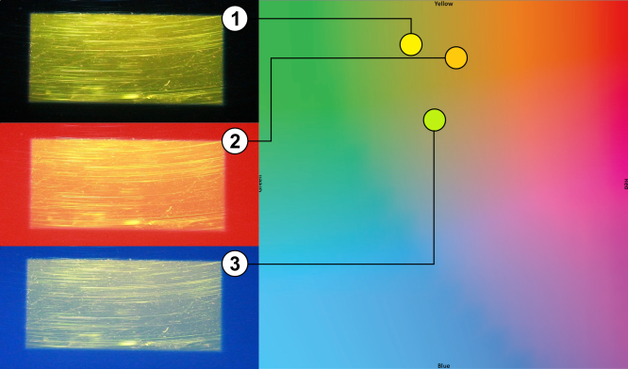

Figure 2. Examples of color blending with a yellow rectangle on (1) no background – black, (2) red and (3) blue backgrounds for the p3700 display.

We propose a color correction algorithm based on the BP model and study it with an extensive set of background and foreground colors. Our results show that using BP-based color correction foreground colors are corrected more accurately for displays with limited color profiles and for background colors of low luminosity, and correction becomes harder when the backgrounds are of high luminosity. For our display with the largest color profile, our approach corrected better light foreground colors, with neutral and cyan performing best.

This paper contributes to the field of optical see-through displays in several ways: 1) we introduce the binned-profile model and validate it against other possible display models, 2) we propose a color correction approach based on the BP model and studied it with a wide range of background and foreground colors, and 3) we discuss the design implications and the challenges associated to incorporating our approach into everyday optical see-through display platforms.

# BACKGROUND AND SCOPE

Color blending is the phenomenon where two colors mix to form a third. Figure 2-left shows examples of color blending in an optical see-through display for a yellow box over three different background conditions: no background (black), red and blue. Figure 2-right shows the corresponding shift in color: the yellow square shifts toward orange when the background is red and toward green when the background is blue. Field studies of AR applications with optical see-through displays reveal that the clarity and legibility of digital colors are affected by color blending such that, the colors in text and icons are altered (change in hue) or washed out (de-saturation) [28]. Such changes affect the user interface and can render it ineffective: e.g. text might turn unreadable when washed out, or color encoded information such as red warning icons might lose their visual meaning.

Gabbard et al. studied such color changes in optical see-through displays [9] by building an experimental test-bed and examining foreground (27 colors on the edge of the RBG gamut) and background colors (6 common outdoor colors – foliage, brick, sidewalk, pavement, white and no background) of different lighting level and hues. Their results showed that high intensity background colors affect all other colors by pulling them towards white and background colors of different hues pull all colors toward them. Gabbard et al. defined the color blended and perceived by a user (CP) as a function of the light source (L1), the reflectance (RF) of a background object (B), the light emitted by the display (L3), the interaction of both L1 and L3 in the display (ARD), and the human perception (HP). See equation 1:



Figure 3. Left: The digital color #FF0000 (white border) and as displayed by different optical see-through displays. Right: The foliage color (white border) and as it is seen through different optical see-through displays.

$CP=HP\left({AR}_{D}\left(L_{3}, RF\left(L_{1}, B\right)\right)\right)$ (1)

Borrowing from spatial AR and projection systems, Weiland et al. address color blending in optical see-through displays [32] by subtracting the background color from the foreground color at a pixel-per-pixel level. This color-blending model ignores the fact that each display shows colors differently, and thus subtraction-based color correction might not be optimal for all displays.

To create a better model we un-wrap the interaction of colors on the display (ARD in equation 1) to account for two externally observable distortions. The first distortion is due to the fact that each display renders digital colors differently. Figure 3-left shows the color red (#FF0000) as displayed by different screens. Figure 1 illustrates this distortion as the difference in hues between the “digital color” (DC) and the “color shown”. The second distortion is due to the display medium changing the background color before blending. Figure 3-right shows the foliage color as seen through different screens. Figure 1 illustrates this distortion as the difference in hues between the “bg color” and the “bg in display” color. In our formulation we simplify the light and reflectance of the background (the RF(L1,B) component of equation 1) into the single entity “background color” (BC). Moreover, we leave the influence of human perception of colors for future work. Thus, we model color blending as follows:

$Blended Color= f_{dDC}\left(DC\right)+ f_{dBC}\left(BC\right)$ (2)

Key to this model is the characterization of the fdDC and fdBC distortion functions. The fdDC function describes the way a particular display shows a given digital color and it is the focus of this paper: we propose the binned-profile model (see section 5), and apply it for color correction on a large set of background and foreground colors (see section 6). The fdBC function describes the way the display medium alters a background color and it is out of the scope of this paper; instead we limit the backgrounds we used and collect objective measures of how they are seen through the display. Unveiling this function requires capturing real world background colors and creating a model of how the display medium affects (hue and luminance) them.

# RELATED WORK

## User, Content and Hardware Solutions

Researchers have long discussed color blending as a significant perceptual challenge for the field of AR [20], especially in outdoor environments [16]. In order to improve the display visibility users resort to strategies like looking for a dark spot (dark surface or shadow) or placing a hand in front of the display [28]. Both strategies require users to switch context between their activity and the display which often results in missing important information. Strategies like these inspired research into ways to improve display clarity. A simple approach is to dynamically increase the intensity of the digital content (mentioned in [18]), however such solution is not always efficient [16]. Leykin and Tuceryan capture the field of view of the user and classify it into zones where digital text would be readable or unreadable [21]. In a similar fashion, Tanaka et al. developed a layout system that relocates digital content to the darker areas of the display [31] taking into account restrictions like ordering of the components.

Color blending also affects the effective occlusion of physical objects by digital content, an important issue when the real environment is enhanced with 3D virtual objects that are intended to look real, such as in architectonical previewing. Without effective occlusion, the virtual object is perceived as translucent and unreal [6] and can confuse users [29]. Solving the occlusion problem keeps digital content from being affected by the physical objects in the background, thus solving the color blending problem. The main approach to solving occlusion has been to stop the light coming from the background by enhancing head-mounted displays with spatial light modulators (SLM) devices [6][17][19][33]. In this approach a black/white depth mask of the scene is generated with the black pixels covering the area where digital content is not to mix with the background light. Therefore, digital colors projected on the black areas are seen in their original hue and lightness. Another solution is to control the illumination of the physical objects in a way that areas behind digital content remain in the dark. Noda et al. explored this approach by constraining physical objects to a dark room [27], while Bimber and Frölich implement it via occlusion shadows in a virtual showcase [3]. Finally, occlusion can be fixed by placing parts of the optical system behind the augmented object, such as Inami et al.’s usage of retro-reflective material as optical camouflage [15].

Our approach differs from these solutions as we aim not to change the location of user interface elements or to add new hardware components to the optical see-through display. Rather we seek to manipulate the color shown by the see-through display; an approach known as colorimetric compensation or color correction.

## Color Correction Solutions

Researchers in the field of projector-based spatial AR studied color correction as a way to enable projections on non-white and textured surfaces. Nayar et al. proposed a camera-based radiometric calibration model to compute the relation between the digital image and the projection on a textured surface [26]. Their approach requires a calibration phase where known patterns are projected on the projection surface and the resulting blended images are processed to obtain compensation matrixes. Bimber et al. extended the range of projectable color by using a transparent film and multiple projectors, taking into account the reflectance and absorption of the digital color by the projection surface [5]. Grossberg et al. extended the radiometric model to include ambient light [11]. While these works deal primarily in the device dependent RGB space, others achieved higher correction accuracy by working on the device independent CIE XYZ color space [24].

Weiland et al. applied color correction to see-through displays by means of color subtraction [32]. Their system was based on Bimber et al [5] with camera on top of the HMD (Head Mounted display) to capture the background. In this paper we continue this line of work but move away from color subtraction. We focus on the actual colors our displays can show and proposed a binned-profile display model. Moreover, we consider background colors as seen through the display. Finally, we use the device independent CIE XYZ and CIE LAB color spaces, extend our study to both projector-based and T-OLED (Transparent Organic Light Emitting Diode) displays, and present results quantitatively.

# EXPERIMENTAL TEST-BED

We designed and built an experimental test-bed to generate various background colors, show colors on multiple see-through displays, and measure the resulting color blending (Figure 4).

To generate different backgrounds we use a Dell U2312HM VGA LCD display calibrated at the standard D65 white point, a white that reproduces the color spectrum as it exists outdoors. This approach to generating background colors is limited by the color gamut of the LCD. Our test-bed takes distance from previous systems [9] which prioritize the capacity to obtain background colors as seen in nature; our design prioritizes the capacity to automatically produce a wide variety of background colors. For our experiments we used background colors from the Macbeth color chart, as they mimic those colors of everyday natural objects like skin color, foliage and flowers. Figure 5A shows the difference between the theoretical background colors and the ones produced and captured in our test-bed.

Our test-bed works with three optical see-through displays: two projector-based and one transparent OLED. The projector-based displays use a 3 mm transparent acrylic surface covered with a Lumisty MFY 2555 film and one of two projectors at 40°. The first projector is an Epson 1705 with 2200 lumens, hereafter called the p2200 display. The second projector is an Epson VS35ow with 3700 lumens, hereafter called the p3700 display. For the transparent OLED display we used a Lenovo S800 phone [12] which has a 240x320 transparent OLED display with 167 ppi, hereafter called the T-OLED display. The T-OLED display is covered in acrylic and with 9 mm total thickness. The test-bed holds the displays at 20 cm in front of the background LCD.

To examine the background, digital colors and the resulting color blends we used the notations of the Commision Internationale de l’Éclairage (CIE) color model. We use the CIE 1931 XYZ color space for color measurement and addition required by equation 2. However the XYZ color space resembles the working of the human visual system which is more sensitive to greens. Therefore, we used the CIE 1976 Lab color space, a perceptually uniform color space, to calculate the perceptual difference between colors; e.g. the distance between a color and its shift when blended, or the distance between a prediction and the measured blend.

To collect data we used a Konica Minolta CS-200 luminance and color meter at 0.2 degrees (standard observer angle). For both p2200 and p3700 displays we measured the XYZ white points of the Lumisty surface at 5 different points: one near the each of the display’s four corners and one in the center. For both projectors all measurements of the white point remained the same. Based on these results we located the colorimeter at 20 cm away from the see-through display and pointing at the center of the display surface. The colorimeter measures colors in the XYZ color space, we converted the measured values into a normalized LAB space using the appropriate white point for each case. After calibrating the background LCD to the D65 white point (measured at 0.9504, 1, 1.0888) we measured two following combinations of the white points per display and recorded the average of 100 measures per combination (see Table 1):



Figure 4. Experimental test-bed, Top: Component diagram. Bottom-Left: Actual set-up with a projector display. Bottom-Right: T-OLED display.

1. See-through showing white and bg LCD turned off.
2. Both see-through and bg LCD showing white.

The displays and the colorimeter were connected to the same controlling computer and were kept away from the ambient light, by a light enclosure (represented in Figure 4 as the dark cave).

|  |  |  |  |  |  |
| --- | --- | --- | --- | --- | --- |
|  |  | **p2200** | **P3700** | **T-OLED** |  |
| **No BG** | **X Y Z** | 0.2655720  0.282182  0.481033 | 0.9504  1  1.0888 | 0.383264  0.395001  0.369982 |  |
| **White** | **X Y Z** | 0.9504  0.990041  1.0888 | 0.9504  1  1.0888 | 0.724775  0.759896  0.727336 |  |

Table 1. White points for all three optical see-through displays.

# THE BINNED PROFILE MODEL

In order to build an open-loop color correction system, it is necessary to have a model of the resulting blend for a given pair of background and foreground colors on a particular display. Providing such estimation requires unveiling the fdDC and fdBC distortion functions of equation 2.

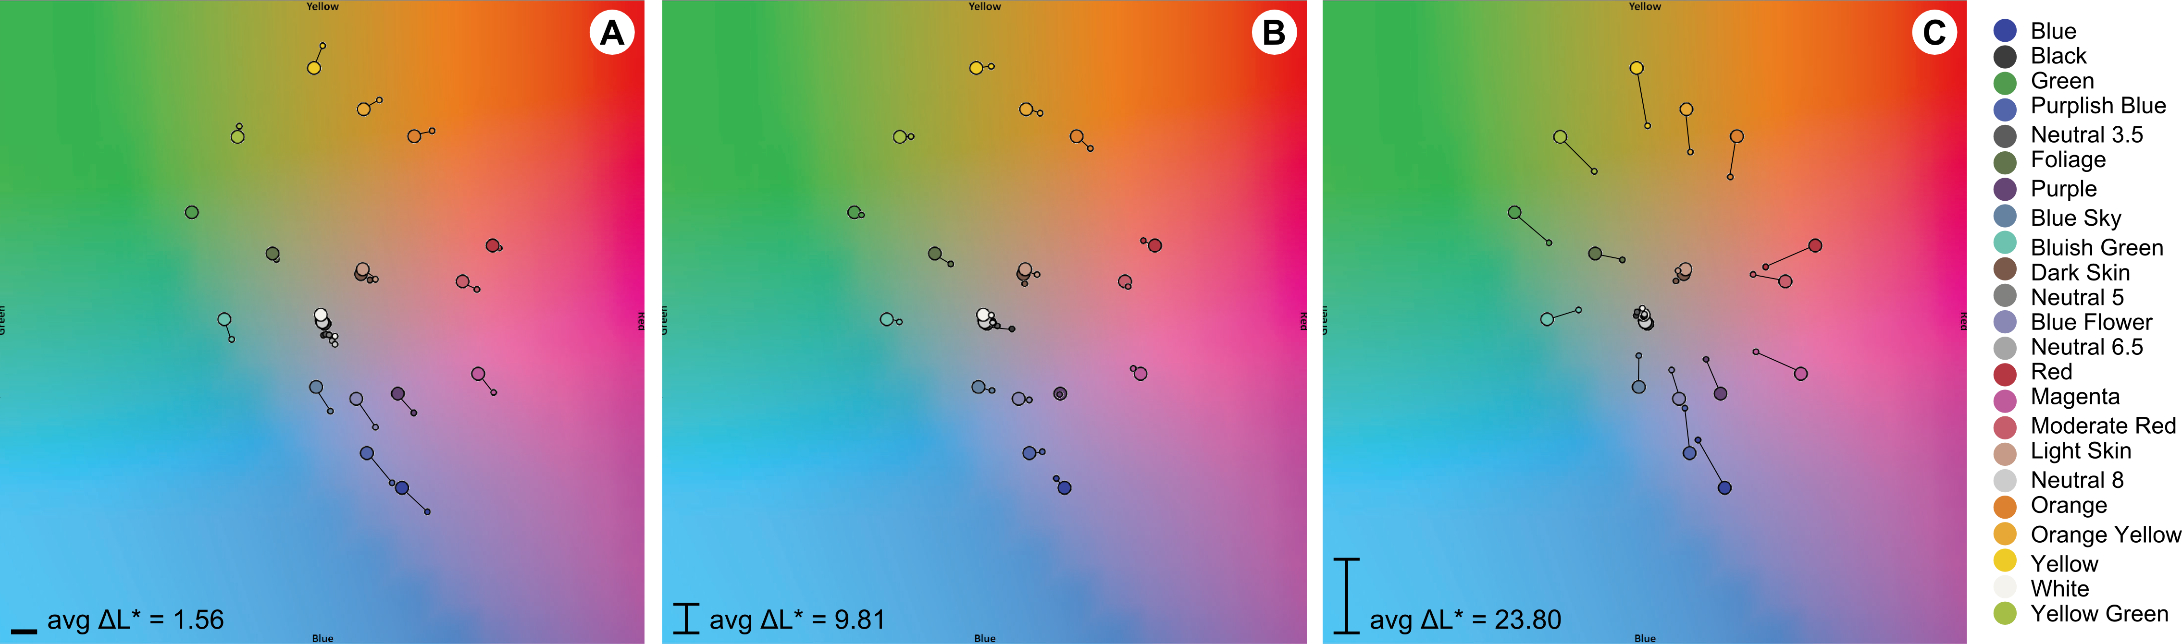

Figure 5. ColorChecker bg colors as (A) shown by the background LCD, (B) as seen through the p2200 and p3700 displays, and (C) as seen through the T-OLED display. Bigger circles = original color. Small circle = measured color.

In this paper we propose a model of the fdDC distortion function called the binned-profile (BP) model. The BP model divides the RGB color space (over 16 million colors) into a smaller set of 8376 perceptually different bins. To create the bins we translate the sRGB gamut into the CIE LAB color space, and divided it into bins of 5×5×5 – a method proposed by Heer and Stone [13]. Guarantying all colors inside a box is within one noticeable difference, such that they are perceived as the same color by a human observer [22]. Figure 6A-B shows the sRGB gamut on the CIE LAB color space and the binned result. Then, we measured how each bin is shown by each of our three display devices. We turned off the background LCD and measured the display reproduction of the whole binned sRBG gamut (8376 colors) for each of our displays. Each color was captured using the colorimeter and the captured XYZ values were transferred into the CIE LAB color space by using the reference white points given in the Table 1 (top row). Based on these measurements we created a look-up table for each display. Figure 6C-E represents the profile for each display with the p3700 almost matching color capacity of sRGB (C), and considerable reductions of color capacity for the p2200 (D) and T-OLED displays (E).

We use each display profile as the core element of the fdDC function. To find out how a display represents a digital color we first translate the display color to its closest bin in LAB space and use the latest as a key in the lookup table. We use the color associated with the key as the one the display actually shows (Color Shown in Figure 1).

BP_prediction(display, foreground, background)

binned_foreground = findBin(foreground)

display_foreground = lookup(display , binned_foreground)

prediction = addXYZ(display_foreground, background)

**return** prediction

Listing 1. Binned-Profile prediction algorithm



Figure 6. (A)s RGB gamut on the LAB color space, (B) the binned gamut, and the binned profile for the (C) p3700 and (D) p2200 projector-based displays, and for (E) for the T-OLED display.

## Binned-Profile Model Validation

In order to assess the validity of BP model for a future color correction system, we explore its capacity to predict color bending and compare it to other approaches. Prediction happens by adding the color given by the fdDC to the background in CIE XYZ and comparing this prediction to the measured blend in CIE LAB. Listing 1 presents how we used the BP model for color prediction. We compare the prediction accuracy of our model against the direct model (DM) and three chromatic adaptation transformation models (CAT). In direct model the digital color is simply added to the background. Chromatic adaptation transformation is an established method to estimate the colors a display can reproduce based on the brightest white it can emit. In other words, CAT could potentially account for the fdDC distortion function of see-through displays. CAT is based on matrices and researchers have proposed CAT models which rely on different matrices. On using the CAT models for our blending predictions; we transformed the foreground color using the respective CAT matrix before adding it to the background. We chose three popular CAT models for our exploration on color blending: Bradford [30], Von Kries [30], and XYZ Scaling [8]. We selected those models due to their popularity in the literature and as a representative set of their kind.

As discussed before, measuring the background color and characterizing the effect of the second distortion (fdBC function) is out of the scope of this paper. We work under the assumption that such color is available at a per-pixel level. However, for the understanding the impact of the distortion, we compare two possible camera-based background detection implementations: pure and distorted. The background color is pure if the system ignores the effect of the second distortion and feeds it to the system as it is measured, so that $f_{dBC}\left(background\right)=background$. The background color is distorted if the system accounts for the second distortion and transforms the color before feeding it to the system (see Bg Color in Display in Figure 1).

We considered 23 of the ColorChecker Color Rendition Chart [23] at D65, a representative set of naturally occurring colors (the 24th ColorChecker color is outside of the sRGB gamut). We measured the colors as shown by the background LCD. These values correspond to the pure background configuration (see Figure 5A). We also measured how each background color would be seen through the see-through displays (see Figure 5B-C). These values correspond to the distorted background configuration for each display. For the background LCD there is a displacement in a and b, however the L remains stable with an average change of 1.56 units in LAB; this means the background LCD displays the ColorChecker colors in a way they are normally seem in nature. For the see-through displays, the data shows displacement in a and b, but also a considerable reduction of L; this is due to the display material absorbing some of the light from the background. It is to be noted that there was a significant impact of the T-OLED display on all axes of the background color.

## Data Collection

we collected a large set of actual color blends, in order to access the prediction accuracy of the BP model and compare with the other models (CM and CATs) under the two background configurations (pure and distorted). We used the 23 ColorChecker colors for backgrounds and 838 random foreground colors (10% of the size of the bin). We measured the resulting blending for each of our three displays capturing a total of 23×838 = 19,274 measurements per display and 19,274×3 = 57,822 measurements in total. We converted the blending measurements into CIE LAB using the white points from Table 1. We predicted the resulting color blend according to the algorithms in listings 1-3 for each combination of prediction model (5), background configuration (2) and display (3). We obtained 5×2 = 10 predictions per blending, 5×2×23×838 = 192,740 predictions per display, for a total of 192,740×3 = 570,822. We computed the accuracy of the predictions by calculating the Euclidian distance in CIE LAB color space between each prediction and the actual measurement.

## Results

Figure 7 summarizes the results for our prediction study using vertical histograms. Each histogram represents the prediction accuracy of all foreground colors for a given background: zero distance in LAB is the bottom of the graph and color intensity represents the height of the histogram. A visual inspection of the results shows that for all conditions the CAT models performed worst, with a high spread in the accuracy and an average far from optimal (in the case of the p3700 display, the CAT models all perform the same due to the fact that the white point of this display is exactly D65). Thus we exclude the CAT models from the rest of this analysis.

Results did not have a normal distribution and therefore we used the Kruskal–Wallis H test for non-parametric data of prediction accuracy. Table 2 shows the results of our analysis. Results showed a main effect of *display*, *model* and *background configuration*. There were also significant interactions effects between all dependent variables. For the p2200 display the BP model performed best in each background configuration (pure: 10.01 – distorted: 4.98). The DM model presented only a small difference between background configurations (pure: 22.71 – distorted: 22.06). We observe a similar pattern for the p3700 display where the BP model has higher prediction accuracy for both background configurations (pure: 10.28 – distorted: 2.77) than the DM model (pure: 17.5 – distorted: 13.67). Finally, when applied to the T-OLED display the BP model also performed better (pure: 25.63 – distorted: 8.24) than the DM model (pure: 34.37 – distorted: 32.26).

|  |  |  |  |  |  |  |
| --- | --- | --- | --- | --- | --- | --- |
| **Display** | **Model** | **Bg-Type** | **df** | **χ2** | **Sig.** | **N** |
| X | -- | -- | 2 | 32152 | < 0.001 | 231288 |
| -- | X | -- | 1 | 698210 | < 0.001 | 231288 |
| -- | -- | X | 1 | 25745 | < 0.001 | 231288 |
| -- | X | X | 3 | 104717 | < 0.001 | 231288 |
| X | X | -- | 5 | 101643 | < 0.001 | 231288 |
| X | -- | X | 5 | 60583 | < 0.001 | 231288 |
| X | X | X | 11 | 142259 | < 0.001 | 231288 |
| **Post Hoc** | | | | | |  |
| -- | Both | Distorted | 1 | 59437 | < 0.001 | 115644 |
| -- | Both | Pure | 1 | 21613 | < 0.001 | 115644 |
| -- | BP | Both | 1 | 52494 | < 0.001 | 115644 |
| -- | DM | Both | 1 | 2157 | < 0.001 | 115644 |

Table 2. Kruskal-Wallis test for prediction accuracy

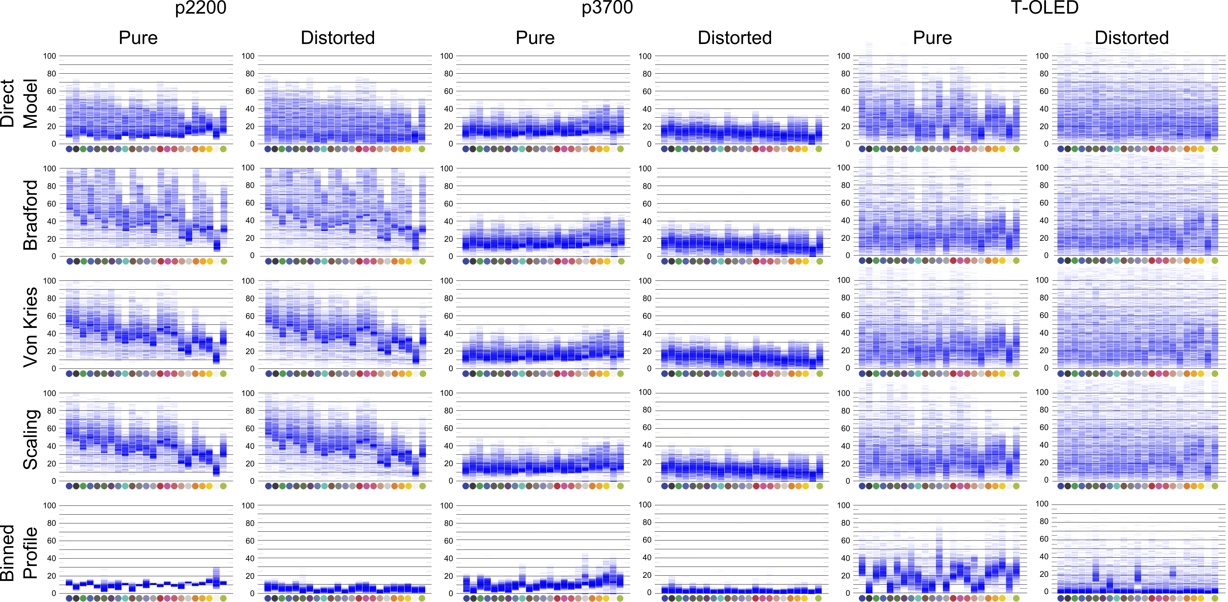

Figure 7. Prediction results of p2200, p3700 and T-OLED displays, with 5 prediction models, and *pure* and *distorted* bg configurations.

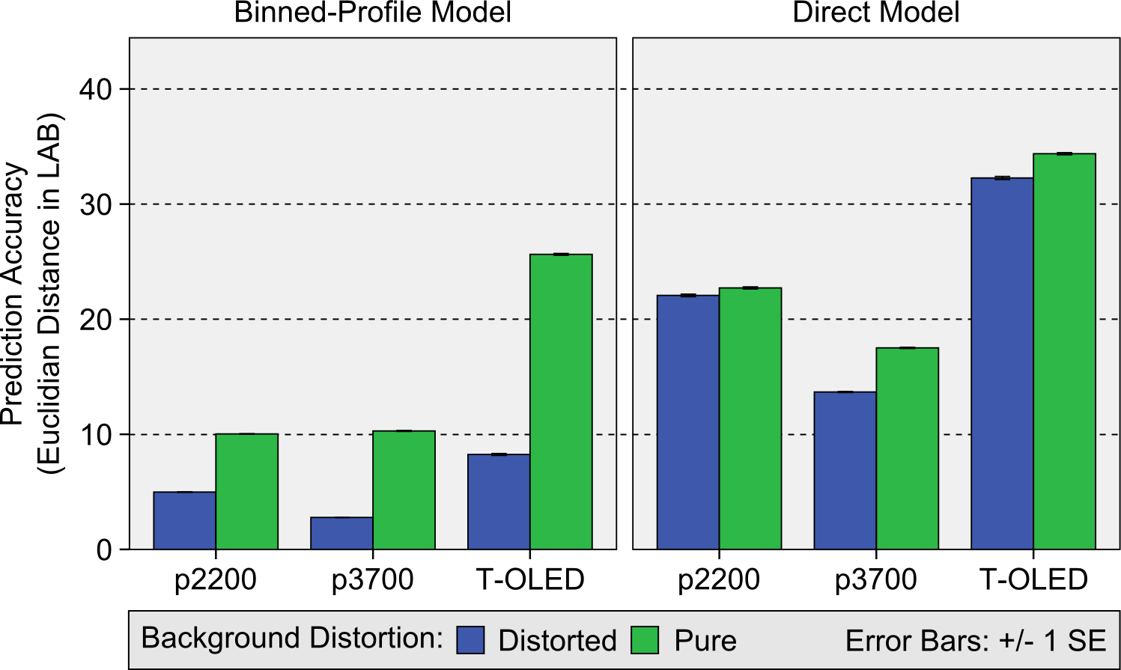

**Figure 8. Prediction accuracy for the three displays, with the BP and DM models, for the two background**

Overall, results show that the BP model outperforms the other prediction models we tested across all 23 background colors. Moreover, this high accuracy exists for both the pure and distorted background configurations. Our results stress the importance of the first display distortion (how the display represents digital color) as the dominant factor for color blending. More importantly, our results highlight the limitations of the direct model (ignoring the display distortion) and the inadequacy of any of the three CAT models we tested. Finally, results show that considering the second distortion improves prediction accuracy, reducing the error by more than half in all displays. For the p3700 display prediction accuracy of the BP model with the distorted background condition was of 2.77 or about 1 JND.

# COLOR CORRECTION

Color correction aims at finding an alternative color which, upon mixing with the background, results with the color originally desired by the designer. In this section we propose an color correction approach for optical see-through displays based on the BP model as explored in section 5. When correcting a color for a given background, the system predicts how each color of that particular display’s profile blends with a particular background. Then the system uses this prediction capacity to finds a color which is the closest to the originally intended color. This algorithm is described in Listing 4. First, the foreground color (foreground - the RGB color the system wants to paint on the screen) is mapped to the closest of the binned RGB colors (binned_foreground - see Figure 6B). Second, based on the display profile, the binned color is mapped to its actual representation (display_foreground - the way such binned color is actually shown by the display). Third, for each color on the display profile, the system predicts its blending with the background (prediction) and measures the distance between the prediction and the display color (tmp_accuracy). The system selects the display color with the highest accuracy (color_to_show) and converts it to the corresponding binned color that produces it via a reverse lookup on the display profile (corrected_color). Finally the display shows the corrected color.

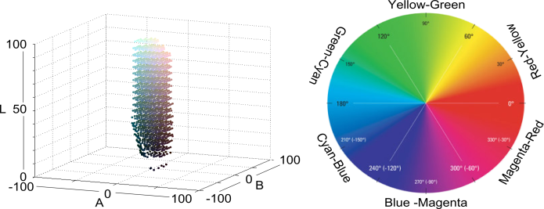

Figure 9. Foreground color groups. Left: neutral colors within 10 JNDs from the L axis. Right: 6 chromatic groups – YellowGreen, GreenCyan, CyanBlue, BlueMagenta, MagentaRed and RedYellow.

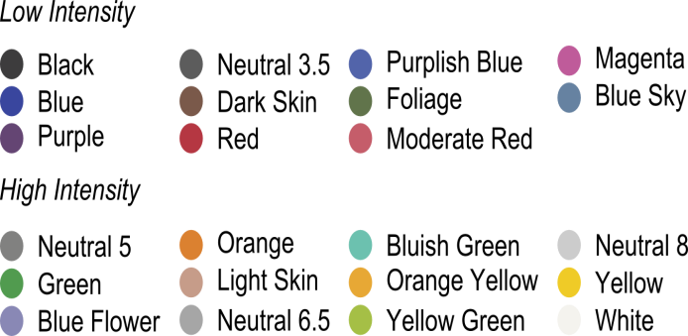

Figure 10. Low and High intensity background groups.

BP_preservation(display, foreground, background)

binned_foreground = findBin(foreground)

display_foreground = lookup(display , binned_foreground)

accuracy = INFINITY

**foreach** color **in** display

prediction = addXYZ(color, background)

tmp_accuracy = distance(prediction, display_foreground)

**if** tmp_accuracy < accuracy

accuracy = tmp_accuracy

color_to_show = color

corrected_color = reverseLookup(display, color_to_show)

**return** corrected_color

Listing 4. Binned-Profile color correction algorithm.

The system selects the display color with the highest accuracy (color_to_show) and converts it to the corresponding binned color It’s important to note that our algorithm aims at correcting the color the display actually shows, rather than the application defined foreground. Moreover, our algorithm avoids using color subtraction (corrected_color = foreground - background) for two reasons: first, similarly to the direct model for color prediction, color subtraction ignores the particular display profile leading to an incorrect target for correction. Second, because color subtraction often results in values for corrected_color which are outside the display profile.

## Data Collection

In this study our goal is to explore how well the algorithm corrects foreground colors for different common backgrounds. We applied the color correction algorithm on the p3700, p2200 and T-OLED see-through displays for the 23 ColorCheck backgrounds in their distorted version. We selected 200 random foreground colors for each background, corrected them, and measured the distance between the display_foreground and the resulting color amounting to 23×200 = 4600 measures per background. We collected a total of 23×200×3=13800 measurements for all three displays. We took a two-step approach to analyzing the collected data. In the first step we looked at the general correction capacity of the algorithm for the three displays. In the second step we focused on the p3700 display as it can reproduce a wider variety of colors (see Figure 6C-E for the color profile of each display). For this display we grouped the foreground colors into 10 groups: dark colors (L < 50), light colors (L > 50), dark and light neutrals (neutrals are located within 10 JNDs of the L axis), and 6 chromatic groups according to the color circle.

Figure 9 shows (left) the dark and light neutrals, and (right) the chromatic groups in the color circle. Note that each foreground might belong to more than one group. Similarly, we divided the ColorCheck backgrounds into high intensity colors resembling daylight conditions like white and yellows, and low intensity colors resembling night conditions like black and blue. Figure 10 shows the background color groups we created.

## Results

For analyzing the correction results we used vertical histograms together with a color heat-map (see Figure 11-Top-Right). The color heat-map reveals how well groups of foreground colors can be corrected for a given set of background colors. The color heat-map divides the 2D AB color map into a 30×30 grid. Each grid cell is colored in blue (#0000FF) with the opacity moving from 0 to 1, where the opacity is relative to the average correction accuracy (ranging from 0 to 100+) of all colors in that cell. If the sample did not contain corrections for foreground colors in a given cell, the cell has no blue box. If the sample contains corrections for a given cell, the accuracy of each correction is calculated and averaged with the rest. Cells in which colors are well corrected in average result in a faint blue. Cells in which colors cannot be corrected in average result in a dark blue. Figure 11 shows the general correction accuracy results for all background and foregrounds colors on the three displays.

A visual inspection of the results reveals that correction works better for low luminosity backgrounds (toward the left of the vertical histogram) for all three displays. Results also show corrections are more accurate for the p2200 and T-OLED displays (fainter blue boxes in the heat-map and more concentrated vertical histograms). This could be explained by the limited range of colors these displays can render (concentrated in a small volume in the LAB color space) and therefore the distance between the measured correction and the target color will always be small. Conversely, corrections are less accurate for the p3700 display, which can be explained by its wider range of colors (occupying a larger volume in the LAB color space) and therefore the distance between the measured correction and the target is larger. Finally, foreground colors toward the edge of the gamut (red, green, blue) generally had lower correction accuracy when compared to the colors located in the central region of the gamut.

Figure 12 shows the correction results for the p3700 display according to high and low intensity backgrounds and the different foreground groups. A visual inspection of Figure 12 shows that BP-based color correction for the p3700 display works best on low intensity (dark) background colors. This is the case for all groups of foreground colors with seemingly better performance in the light foregrounds. For high intensity (light) backgrounds we observed a decreased correction capacity across all foreground colors, and a particularly acute decrease on dark foregrounds and on the outer areas of all color groups (more saturated colors). We also observed that the region of neutral colors might be larger than we originally thought as similar levels of correction accuracy might be found at a bigger radius. For both background conditions the light neutrals present lighter heat-maps.



Figure 11. Correction results overview for the three displays.

Figure 13 gives a quantitative view of the correction accuracy for the chromatic groups and the neutrals for the p3700 display. We analyzed this data using the Kruskal–Wallis H test (see Table 3). The results show there is a significant difference between corrections of each chromatic region, Background intensity, foreground luminosity conditions respectively with high significance value. On post Hoc testing the results show there was a significant difference for various background intensity × foreground luminosity conditions. It was also shown all colors irrespective of neutral or non-neutral were corrected to a good extend in low intensity background conditions. However, neutral color are compensated significant different than the non-neutral colors for high luminosity background. In general corrections were more accurate for low intensity backgrounds at 21.23 (9.2 JNDs), for light foregrounds at 23.46 (10 JNDs), and the CyanBlue group at 31.49 (13.6 JNDs). In general corrections were more accurate for the low intensity backgrounds at 18.81 (8.1 JNDs) and for light neutrals at 10.91 (4.74 JNDs).

|  |  |  |  |  |  |  |  |
| --- | --- | --- | --- | --- | --- | --- | --- |
| **Color Region** | **BG Type** | **FG Type** | **Neutral** | **df** | **χ2** | **Asymp Sig.** | **N** |
| All | -- | -- | -- | 5 | 23.9 | < 0.001 | 4600 |
| -- | Both | -- | -- | 1 | 1056.5 | < 0.001 | 4600 |
| -- | -- | Both | -- | 1 | 761.9 | < 0.001 | 4600 |
| -- | -- | -- | Both | 1 | 46.5 | < 0.001 | 4600 |
| **Post Hoc** | | | | | | | |
| -- | Low | Both | -- | 1 | 381.7 | < 0.001 | 1602 |
| -- | High | Both | -- | 1 | 651.1 | < 0.001 | 2988 |
| -- | Both | Dark | -- | 1 | 684.2 | < 0.001 | 1785 |
| -- | Both | Light | -- | 1 | 685.4 | < 0.001 | 2815 |
| -- | Low | -- | Both | 1 | 6.3 | < 0.05 | 1602 |
| -- | High | -- | Both | 1 | 66 | < 0.001 | 2988 |

Table 3. Kruskal-Wallis test for correction accuracy

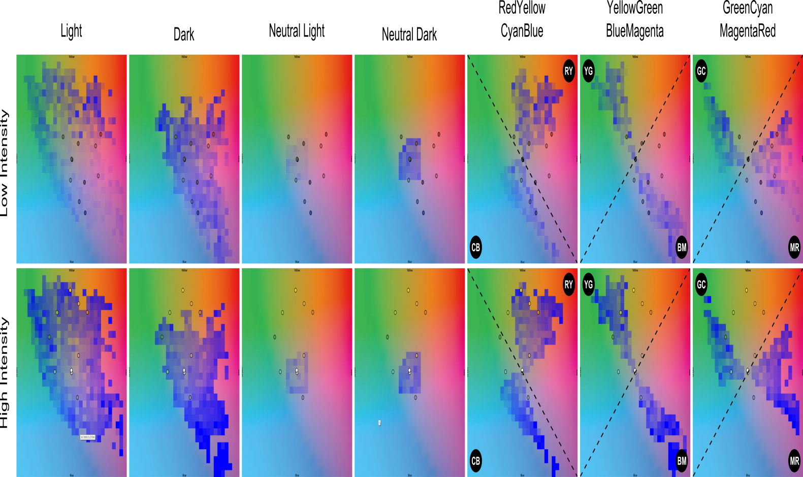

Figure 12. Correction results for the p3700 display of the groups of foreground colors according to high/low intensity backgrounds.

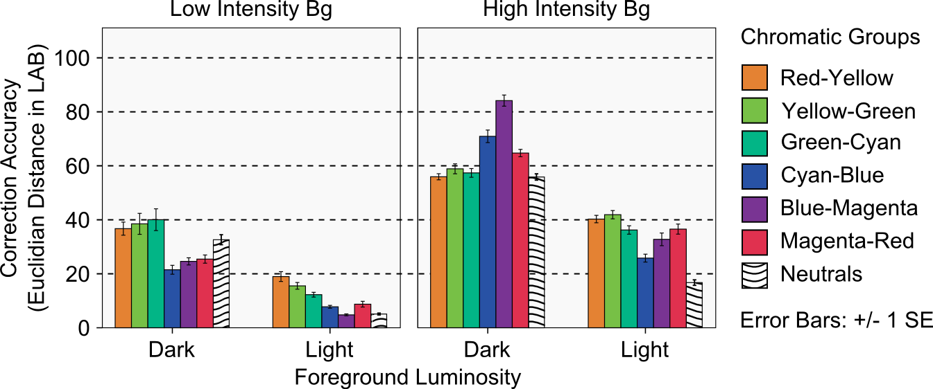

Figure 13. Quantitative analysis of correction accuracy using the BP model for the p3700 display.

Overall, results show that colors can be better corrected for displays with a lower color capacity as we have shown for the p2200 and T-OLED displays. This can be explained by the fact that the display profile is a small volume and therefore distances between the corrected color and the originally intended will always be short. The trade-off is that such displays cannot really convey realistic color experiences. More interesting are the results for the p3700 display, a display with a larger color profile as you would expect in a general purpose multimedia device. This results show that the BP-model can achieve highly accurate corrections for low intensity backgrounds (such as the ones in dark environments or night conditions), particularly for light colors on the display. Moreover, for high intensity backgrounds (such as the ones in daylight conditions) the BP-model achieves its best corrections for light foregrounds, particularly for the neutrals and the colors of the Cyan-Blue family. Finally, the BP-model presents a consistently low accuracy for correcting dark foregrounds, with opposite trends depending on the background. For low intensity backgrounds Cyan-Blue, Blue-Magenta and Magenta-Red are corrected best, however, for high intensity backgrounds it is Red-Yellow, Yellow-Green, Green-Cyan and the neutrals that are corrected best.

# DISCUSSION

This section discusses the applicability of BP-based color correction, display hardware, and design implication for interface designers.

## Practical Applicability

Implementing BP-based color correction requires a display profile and mechanism to determine how background objects interact with the individual pixels of the display. Ideally, the display manufacturer provides such profile and makes it available for developers. In a head-mounted display, the system can use a digital camera for a pixel-per-pixel mapping of the background and the display image such as in [5][32]. However, accurate color measurement via a digital camera itself a complex task [14], especially for changing light conditions like outdoors. A correctly calibrated camera can provide basic background color measurements. For a window-size transparent display such a camera-based method is not adequate as it is impossible to locate a camera on the user’s vantage point. In such case the system could rely on a 3D model of the background with projections of the lighting for a given perspective. Both solutions can support color correction for the *pure* background condition. However, neither of these configurations accounts for the second display distortion as shown in equation 2.

To account for the second distortion the system should accurately predict how a given background is modified by the display medium. A preliminary assessment of a 100 colors on the L axis shows the amount of L absorbed by the display medium could be explained by a linear function (see Figure 14). The effect of the display medium on L is considerable, particularly for the T-OLED display for which L is reduced by almost half. Further work is required to confirm this trend and to characterize the effect on the hue (A and B).

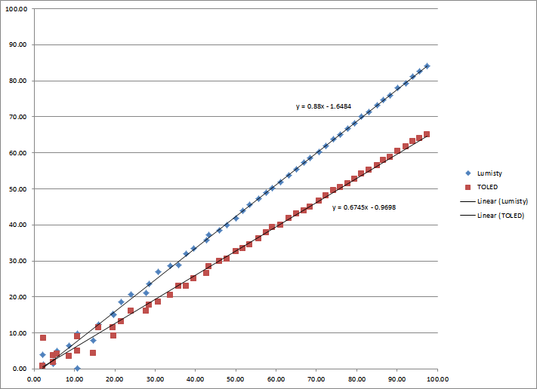

Figure 14. Effect of the display medium on background L appears to be linear.

## Display Hardware

We showed an optical see-through display affects color blending through its color profile and its impact on background colors. Limited color profiles such as in the p2200 and T-OLED displays guarantee better color correction when using the BP-model. However, such limited color displays provide a limited color experience for applications like video or game playing. On the other side, full color displays like our p3700 could provide richer color experiences at the cost of less correction accuracy. A promising exploration venue is full color displays with a lower level of transparency. Lower transparency darkens background colors which, as we observed in the correction study, provide better conditions for color correction. The degree of opacity of the display poses a challenge for how much accessibility and clarity is needed for either the background or the display content.

Ideally, an optical see-through display should provide a way to control the level of transparency at a pixel level, as explored by [17]. A rendering system could rely on BP-based color correction for darker backgrounds and block background light as the correction algorithm approaches its limits (i.e. when the background color makes the foreground color uncorrectable).

## Design Implications

A major result from our correction study is that, with BP-based color correction, designers can use light neutral colors for information that needs to be preserved best. Should more he be needed, designers can use light color in the CyanBlue region. Dark colors should be avoided for color-encoded information, although they can still provide good contrast for, e.g., text legibility.

An important corollary is that, even with BP-based color correction, not all foreground colors can be corrected. The degree by which a foreground color can be corrected depends to a great extent on the background color. Therefore, interface designers should study the intended normal usage conditions of their application, in order to collect prevalent background colors. Based on such set, designers can analyze the correct-ability of alternative color pallets on such backgrounds and stick with the one pallete with the higher accuracy.

# CONCLUSION

This paper presents an open-loop approach to color correction in optical see-through displays based on two color distortions introduced by the display medium: a distortion in the way the display represents colors and a distortion on the background color before it blends with the color on the display. The paper focuses on addressing the first distortion and proposes the Binned-Profile (BP) model, a colorimetric model of how a particular display renders a representative set of colors of the RGB gamut. For the second distortion we used colorimetric measurements of how background colors are seem through the display medium. We validated the BP-model by measuring the accuracy of its color blend predictions on three different optical see-through displays against other known methods. The results showed that the BP model outperforms other methods, and that this first distortion is the main factor to address for correct color blend predictions.

We presented a color correction algorithm based on the display color profile of the BP-model and investigated its correction capacity using a wide variety of background and foreground colors for our three displays. Results showed BP-based color correction works best for displays with low color capacity. Moreover, for displays with high color capacity results show that colors can be better corrected for low intensity backgrounds, and that for high intensity backgrounds light neutrals colors and CyanBlue colors can be corrected best. We reported our results both graphically (through vertical histograms and heat-maps) and quantitatively.

We finalized with a discussion on the applicability of BP-based color correction including some ideas about addressing the second distortion, the impact of display hardware, and implications for interface designers using the BP-model. Our future work includes characterizing the second distortion along the lines expressed in the discussion, and testing our approach in the wild with user participants and for different display hardware (i.e. head-mounted displays and window-size transparent displays).

# REFERENCES

1. Ashdown, M., Okabe, T., Sato, I., Sato, Y. 2006. Robust Content-Dependent Photometric Projector Compensation. In Proc. CVPRW '06. Vol. 6, No 6, PP 17-22.
2. Azuma, R., Baillot, Y., Behringer, R., Feiner, S., Julier, S., and MacIntyre, B. 2001. Recent Advances in Augmented Reality. IEEE Comput. Graph. Appl. 21, 6.
3. Bimber, O., and Fröhlich, B. 2002. Occlusion Shadows: Using Projected Light to Generate Realistic Occlusion Effects for View-Dependent Optical See-Through Displays. In Proc. ISMAR '02.
4. Bimber, O. and Raskar, R. 2005. Spatial Augmented Reality: Merging Real and Virtual Worlds. A. K. Peters, Ltd., Natick, USA.
5. Bimber, O., Emmerling, A., and Klemmer. T. Embedded Entertainment with Smart Projectors. IEEE Computer, 38(1):48–55, 2005.
6. Cakmakci, O., Ha, Y., and Rolland, J.P. 2004. A Compact Optical See-Through Head-Worn Display with Occlusion Support. In Proc. ISMAR '04. IEEE.
7. Carmigniani, J., Furht, B., Anisetti, M., Ceravolo, P., Damiani, E., and Ivkovic, M. 2011. Augmented reality technologies, systems and applications. Multimedia Tools Appl. 51, 1.
8. Chromatic Adaptation. (2013, April 23). Chromatic Adaptation. (2009) [Website]. Retrived from http://www.brucelindbloom. com/index.html?Eqn_ChromAdapt.html
9. Epson Moverio, (2013, May 15). EPSON Moverio BT-100 - Android Powered Interactive Display - Epson America, Inc. (2012) [Website]. Retrieved from <http://www.epson.com/cgi-bin/Store/jsp/Moverio/Home.do?BV_UseBVCookie=yes>
10. Gabbard, J.L., Swan, J.E., Zedlitz, J., and Winchester, W.W. 2010. More than meets the eye: An engineering study to empirically examine the blending of real and virtual color spaces. In Proc. VR '10. IEEE.
11. Grossberg, M.D., Peri, H., Nayar, S.K., and Belhumeur, P.N. Making one object look like another: controlling appearance using a projector-camera system. 2004. In Proc. CVPR 2004.
12. GSM arena. (2013, March 19). Lenovo S800 – Full phone specifications. (2011) [Website]. Retrieved from <http://www.gsmarena.com/lenovo_s800-4862.php>.
13. Heer, J., and Stone, M. 2012. Color naming models for color selection, image editing and palette design. In Proc. CHI '12. ACM.
14. Hong,G. Luo,MR. and Rhodes,PA., 2001. A study of digital camera colorimetric characterisation based on polynomial modelling. Color Research and Application, 26(1), pp. 76-84.
15. Inami, M., Kawakami, N., Sekiguchi, D., Yanagida, Y., Maeda, T., and Tachi, S. 2000. Visuo-Haptic Display Using Head-Mounted Projector. In Proc. VR '00. IEEE.
16. Kerr, S.J., Rice, M.D., Teo, Y., Wan, M., Cheong, Y.L., Ng, J., Ng-Thamrin, L., Thura-Myo, T., and Wren, D. 2011. Wearable mobile augmented reality: evaluating outdoor user experience. In Proc. VRCAI '11. ACM.
17. Kiyokawa, K., Billinghurst, M., Campbell, B., and Woods, E. 2003. An Occlusion-Capable Optical See-through Head Mount Display for Supporting Co-located Collaboration. In Proc. ISMAR '03.
18. Kiyokawa, K., Kurata, Y., and Ohno, H. An optical see-through display for mutual occlusion with a real-time stereovision system, Computers & Graphics, Volume 25, Issue 5, October 2001, Pages 765-779.
19. Kiyokawa, K., Ohno, H., and Kurata, Y. 2002. Occlusive optical see-through displays in a collaborative setup. In Proc. SIGGRAPH '02. ACM.
20. Kruijff, E.; Swan, J.E.; Feiner, S., 2010. Perceptual issues in augmented reality revisited. In Proc. ISMAR’10. IEEE.
21. Leykin, A. and Tuceryan, M. 2004. Automatic Determination of Text Readability over Textured Backgrounds for Augmented Reality Systems. In Proc. ISMAR '04. IEEE.
22. Mahy, M., Eyckden, L.V. and Oosterlinck, A. Evaluation of uniform color spaces developed after the adoption of CIELAB and CIELUV. Color Res. Appl., vol. 19, no. 2, pp. 105–121, Apr. 1994.
23. McCamy, C. S., Marcus, H., and Davidson, J. G. (1976). "A Color-Rendition Chart". Journal of Applied Photographic Engineering 2(3). 95–99.
24. Menk, C., Koch, R. Interactive visualization technique for truthful color reproduction in spatial augmented reality applications. In Proc. ISMAR ’11. 26-29. Oct. 2011.
25. Mitsunaga, T., Nayar, S.K.. Radiometric self-calibration. Computer Vision and Pattern Recognition. 1999. IEEE Computer Society Conference on. , vol.1, no., pp., 380 Vol. 1, 1999.
26. Nayar, S. K., Peri, H., Grossberg, M. D., and B. P. N. A projection system with radiometric compensation for screen imperfections. In Proc. of International Workshop on Projector-Camera Systems, 2003.
27. Noda, S., Ban, Y., Sato, K., and Chihara, K. 1999. An Optical See-Through Mixed Reality Display with Realtime Rangefinder and an Active Pattern Light Source. Transactions of the Virtual Reality Society of Japan, 4(4), 665-670.
28. Pingel, T. J., & Clarke, K. C. Assessing the usability of a wearable computer system for outdoor pedestrian navigation. Autocarto 2005.
29. Sekuler, A.B. and Palmer. S.E. "Perception of partly occluded objects: A microgenetic analysis." Journal of Experimental Psychology: General 121.1 (1992): 95.
30. Susstrunk, S. E., Holm, J. M., & Finlayson, G. D. (2000, December). Chromatic adaptation performance of different RGB sensors. In Photonics West 2001-Electronic Imaging (pp. 172-183). International Society for Optics and Photonics.
31. Tanaka, K., Kishino, Y., Miyamae, M., Terada, T., and Nishio, S. 2008. An information layout method for an optical see-through head mounted display focusing on the viewability. In Proc. ISMAR '08. IEEE.
32. Weiland, C., Braun, A.K., and Heiden, W. 2009. Colorimetric and Photometric Compensation for Optical See-Through Displays. In Proc. UAHCI '09. Springer-Verlag.
33. Zhou, Y., Ma, J.T., Hao, Q., Wang, H., and Liu, X.P. 2007. A novel optical see-through head-mounted display with occlusion and intensity matching support. In Proc. Edutainment'07. Springer-Verlag, Berlin, Heidelberg, 56-62.